**Blinkit Data Analysis**

**BUSINESS REQUIREMENT**

To conduct a comprehensive analysis of Blinkit's sales performance, customer satisfaction, and inventory distribution to identify key insights and opportunities for optimization using various KPIs.

#### KPI’s Requirements

1. **Total Sales**: The overall revenue generated from all items sold.
2. **Average Sales**: The average revenue per sale.
3. **Number of Items**: The total count of different items sold.
4. **Average Rating**: The average customer rating for items sold.

select * from blinkit_data

select count(*) from blinkit_data

**Data Cleaning**

update blinkit_data

set Item_Fat_Content =

case

when Item_Fat_Content in ('LF','low fat') then 'Low Fat'

when Item_Fat_Content = 'reg' then 'Regular'

else Item_Fat_Content

end

select distinct(item_fat_content) from blinkit_data

**Q.1 TOTAL SALES BY FAT CONTENT**

**ANS**:

select Item_Fat_Content,

cast(sum(Total_Sales) as decimal(10,2)) as Total_sales,

cast(avg(Total_Sales) as decimal(10,1)) as Avg_Sales,

count(*) as No_Of_Items,

cast(avg(Rating)as decimal(10,2)) as Avg_Rating

from blinkit_data

group by Item_Fat_Content

order by Total_Sales desc;

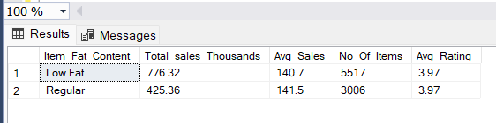

**Q.2 TOTAL SALES BY ITEM TYPE**

**ANS**:

select Top 5 Item_Type,

cast(sum(Total_Sales)/1000 as decimal(10,2)) as Total_sales,

cast(avg(Total_Sales) as decimal(10,1)) as Avg_Sales,

count(*) as No_Of_Items,

cast(avg(Rating)as decimal(10,2)) as Avg_Rating

from blinkit_data

group by Item_Type

order by Total_sales desc;

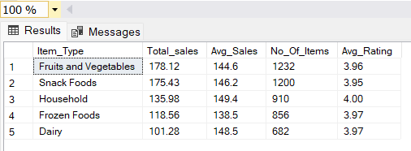

**Q.3 FAT CONTENT BY OUTLET FOR TOTAL SALES**

**Ans:**

select outlet_location_type,

isnull([Low Fat],0) as Low_Fat,

isnull([Regular],0) as regular

from

(

select Outlet_Location_Type ,Item_fat_content,

cast(sum(Total_Sales)/1000 as decimal(10,2)) as Total_sales

from blinkit_data

group by Outlet_Location_Type,Item_Fat_Content

) as SourceTable

PIVOT

(

sum(total_sales)

for item_fat_content in ([Low Fat],[Regular])

) as PivotTable

Order by outlet_location_type;

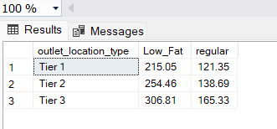

**Q.4 TOTAL SALES BY OUTLET ESTABLISHMENT**

**Ans:**

Ans= select Outlet_Establishment_Year,

cast(sum(Total_Sales)/1000 as decimal(10,2)) as Total_sales,

cast(avg(Total_Sales) as decimal(10,1)) as Avg_Sales,

count(*) as No_Of_Items,

cast(avg(Rating)as decimal(10,2)) as Avg_Rating

from blinkit_data

group by Outlet_Establishment_Year

order by Total_sales asc;

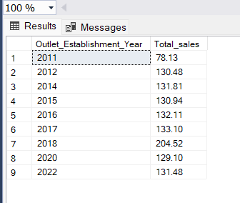

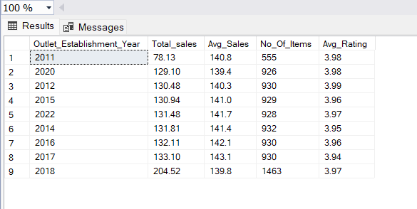

**Q.5 SALES BY OUTLET SIZE**

**Ans:**

select Outlet_Size,

cast(sum(Total_Sales) as decimal (10,2)) as Total_Sales,

cast((sum(Total_Sales)*100.0/sum(sum(Total_Sales))over ()) as decimal(10,2)) as Sales_Percentage

from blinkit_data

group by Outlet_Size

order by Total_sales DESC;

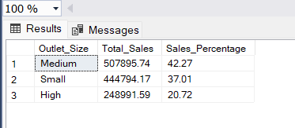

**Q.6 SALES BY OUTLET LOCATION**

**Ans:**

select Outlet_Location_Type,

cast(sum(Total_Sales)/1000 as decimal(10,2)) as Total_sales,

cast((sum(Total_Sales)*100.0/sum(sum(Total_Sales))over ()) as decimal(10,2)) as Sales_Percentage,

cast(avg(Total_Sales) as decimal(10,1)) as Avg_Sales,

count(*) as No_Of_Items,

cast(avg(Rating)as decimal(10,2)) as Avg_Rating

from blinkit_data

group by Outlet_Location_Type

order by Total_sales DESC;

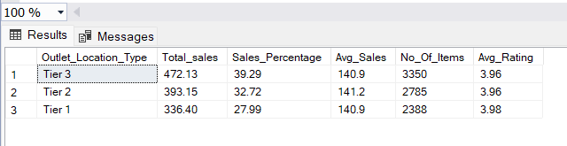

**Q.7 ALL METRICS BY OUTLET TYPE**

**Ans:**

select Outlet_Type,

cast(sum(Total_Sales)/1000 as decimal(10,2)) as Total_sales,

cast((sum(Total_Sales)*100.0/sum(sum(Total_Sales))over ()) as decimal(10,2)) as Sales_Percentage,

cast(avg(Total_Sales) as decimal(10,1)) as Avg_Sales,

count(*) as No_Of_Items,

cast(avg(Rating)as decimal(10,2)) as Avg_Rating

from blinkit_data

group by Outlet_Type

order by Total_sales DESC;

